105 – 1750 West 75th Avenue, Vancouver, B.C., Canada V6P 6G2
Phone: 604.261.9450 Fax: 604.261.2256 www.setbc.org

Coding & Computational Thinking
Introduction
This is a brief overview of how to implement the TouchChat pages below within the BC Curriculum. Grade levels below are only suggested. Many of the activities can be adjusted to suit any grade level. The resource does not preclude students continuing to build their expertise with Core language on their AAC device.

Curriculum Connections
Big Ideas: | Grades:
Skills can be developed through play | K - 3
Complex tasks require the sequencing of skills | 3-9
Complex tasks require different technologies at different stages | 3-9

Curricular Competencies
I can…
Solve problems (debug)
Listen to instructions
Find repetitive patterns
Give specific instructions
Plan a step-by-step sequence of actions
Explain my thinking to others
Break down problems into smaller parts
Make prototypes to improve my work
Collaborate with others to achieve an outcome

Learning Experiences
These pages sets help students communicate step-by-step instructions that tell a peer or a robot what to do. There are many challenges that student can complete in order to practice the principles of computational thinking. For example, making Cubetto or any robot move from Point A to Point B, or invent a dance for others to follow. Page sets may need to be customized so that they are geared to their student’s specific goals for comprehension and vocabulary.
Sample Essential Question: How can I get a robot to go from point A to point B ?
Cubetto:
Choose a start point and an end point on the map. Plan step-by-step instructions to move Cubetto from point A to point B. If you do not reach the desired destination, try again (debug).
Sphero:
Plan out step by step instructions to move Sphero through a maze (for example, a maze of masking tape on the carpet). .
Dance Moves:
Plan out step-by-step instructions to make other students dance to your choreography. If the dancers move according to your choreography, great! If not, add, change or rearrange the steps to try again.

TouchChat vocabulary pages
1 | Cubetto  Resource type: Communication Board, TouchChat  Topic: ADST, coding, TouchChat  Grade(s): K - 3  Created by: Jessy To | 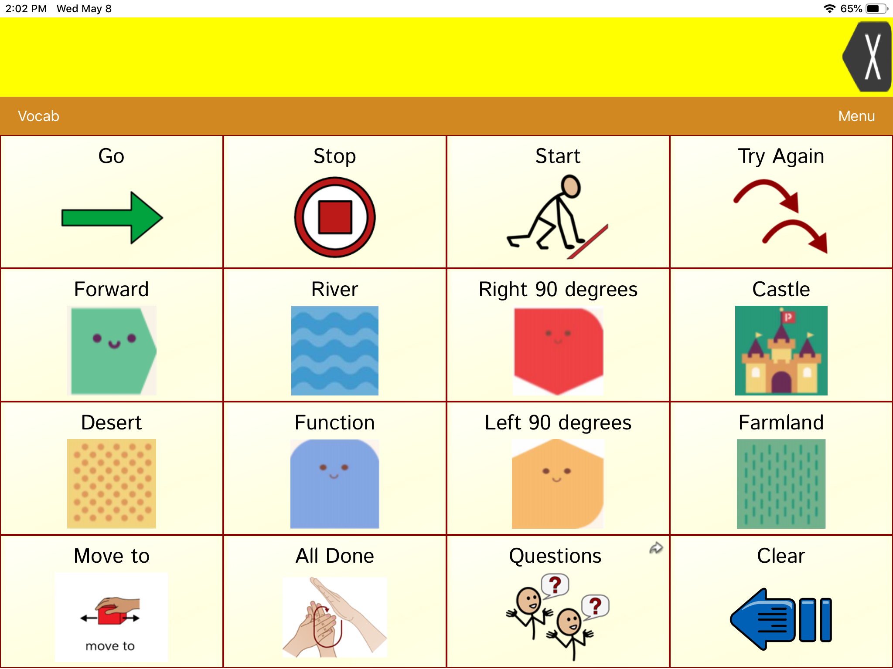
2 | Sphero  Resource type: Communication Board, TouchChat  Topic : ADST, coding, TouchChat  Grade(s) : 3-9  Created by : Lorena Duran | 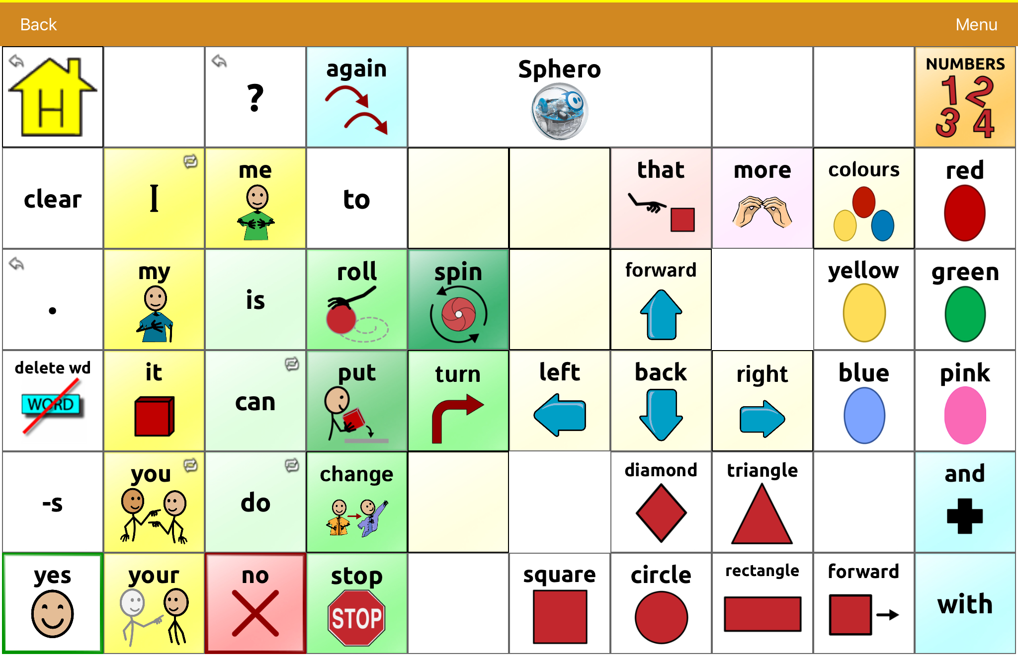
3 | Dance Moves - WP 60  Resource type: Communication Board, TouchChat  Topic(s): ADST, coding, TouchChat  Grades 1-5  Created by: Lorena Duran | 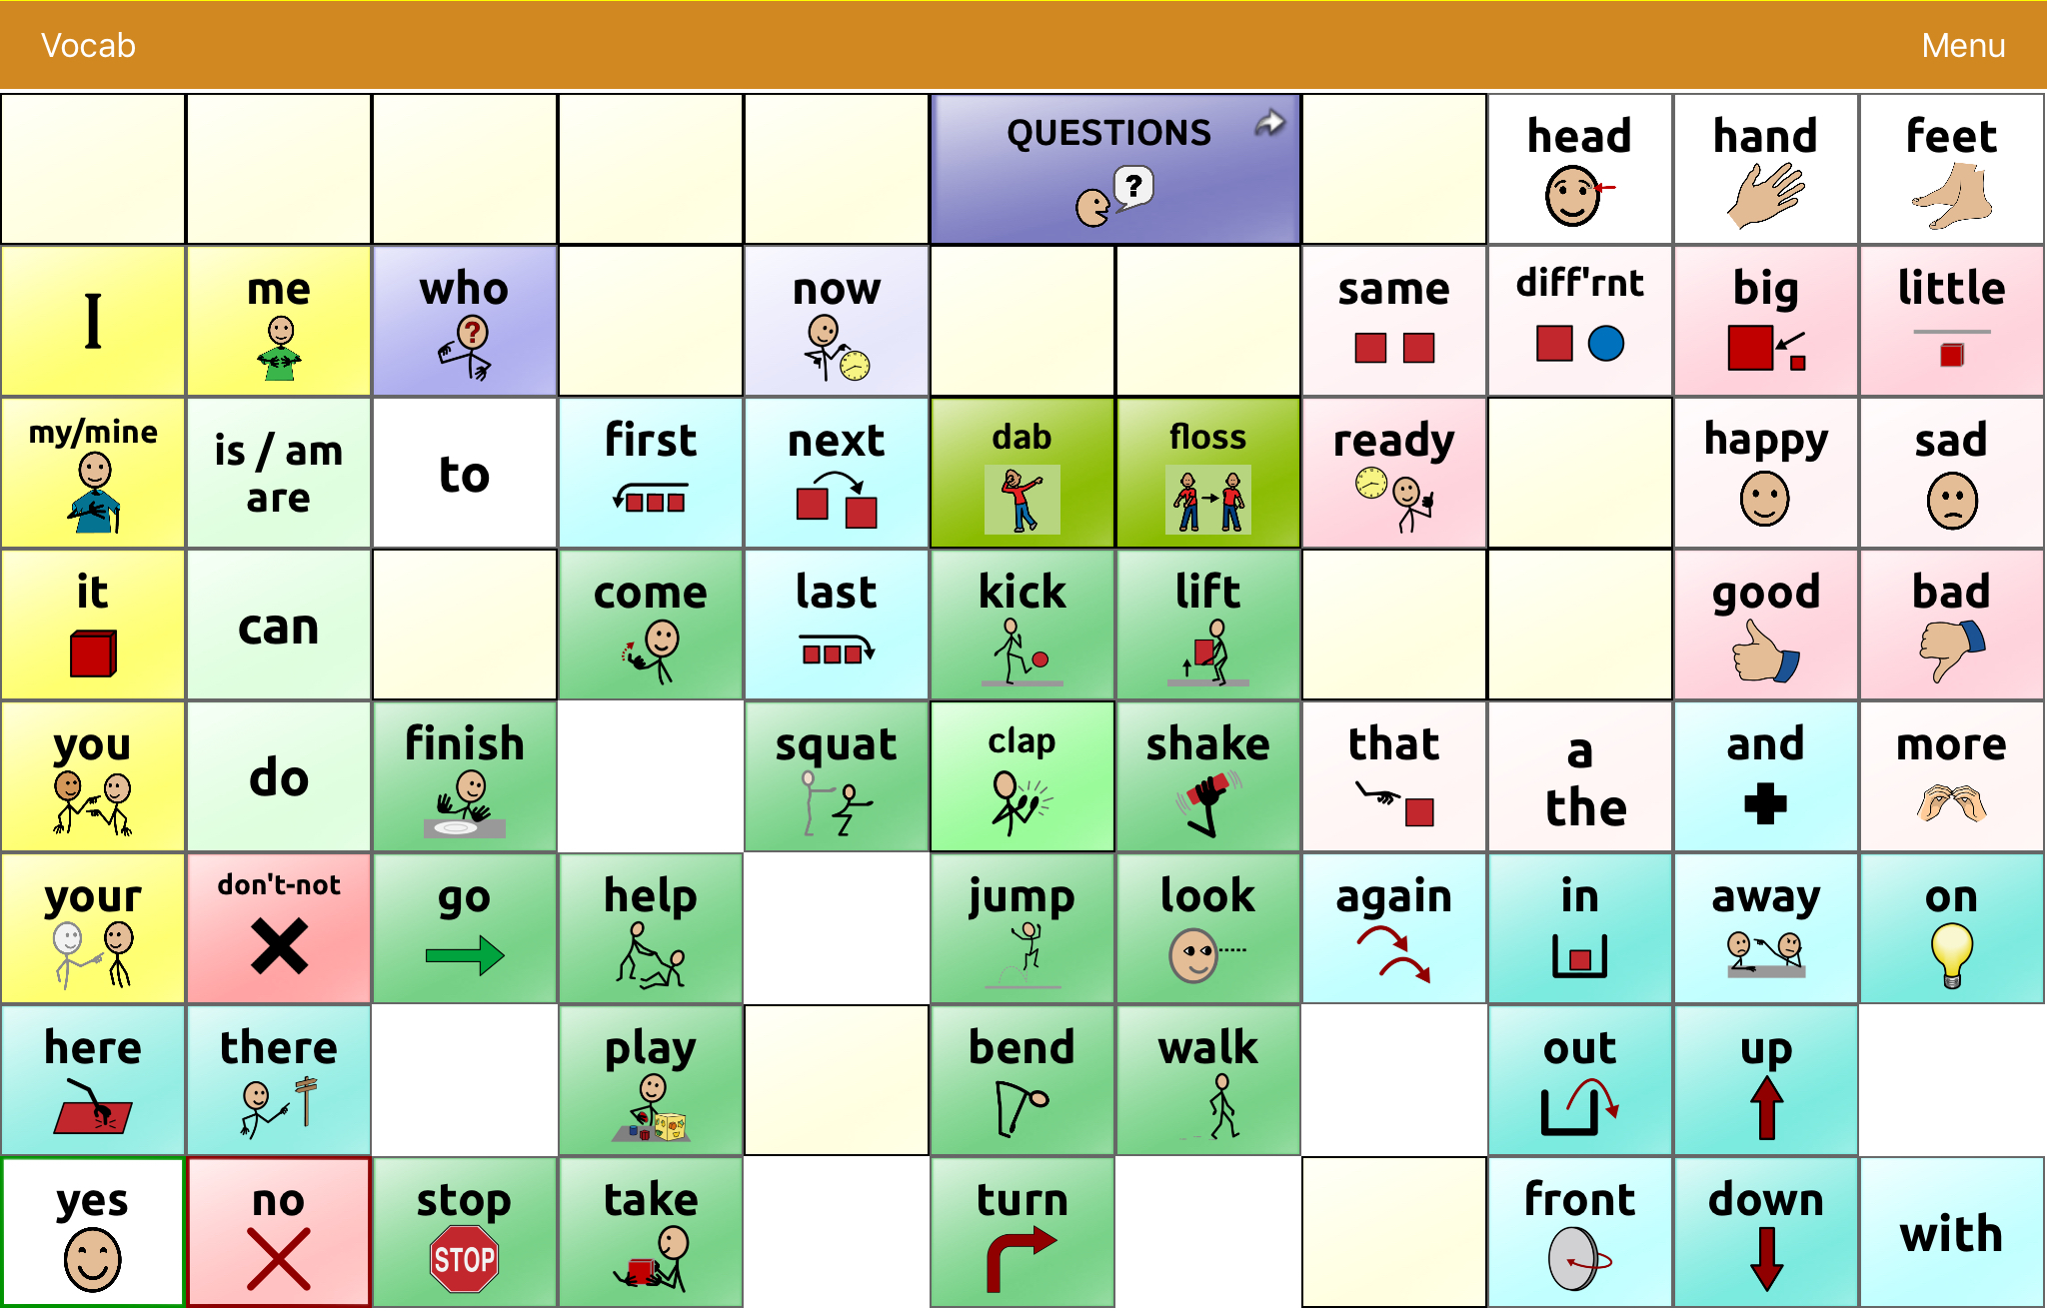
4 | Dance Moves - WP 20  Resource type: Communication Board  Topic(s): ADST, coding, TouchChat  Grades 1-5  Created by: Lorena Duran | 