The Napoleonic Era
Napoleon Bonaparte was an intelligent and ambitious young man who came to power during the French Revolution. He was a soldier with revolutionary ideas and he became a powerful ruler of France and later, much of Europe. He had more power than almost any other person in history. People admired, as well as were terrified of him. He brought an end to many dishonest and greedy monarchies. He created a new law code based on the principles of Enlightenment and created a new court system. He created new school systems, universities and hospitals. The one principle of Enlightenment he did not support was the rights of women.
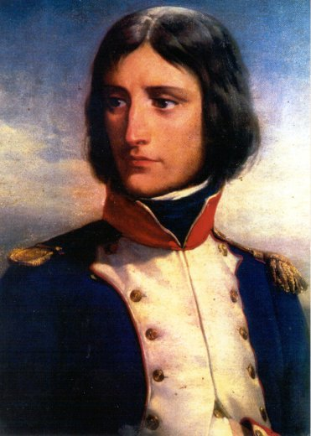
Napoleon was born in Corsica. This island was ruled by France at the time of his birth but is now ruled by Italy. His family belonged to a lower ranking noble class. His father was invited to represent Corsica at a government meeting in Versailles and he took his son along. His father put him in a military school in France. Napoleon’s father died when he was 16 years old. He was made the legal head of the family. He stayed in France and became an artillery officer. He had a strong memory and could remember where every cannon, horse and soldier was at all times. He became one of the youngest generals in the army. He hated mob violence and was called upon to save the Convention from the French citizens. Hundreds were killed in this battle and, as a reward, he was given command of the French army fighting in Italy.

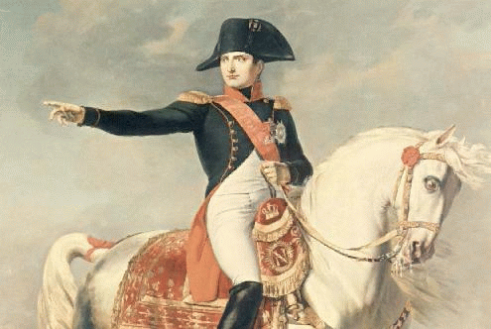
Campaigns in Italy and Egypt
Revolutionary ideas spread across Europe. Ordinary people wanted the corrupt governments and privileged classes to lose their power. In Italy, Jacobin clubs could be found in most big cities. Italians wanted to get rid of their Austrian rulers, but they didn’t want to be ruled by France. Napoleon told them he would respect their property, religion and customs. In 1796, Napoleon defeated the Austrians in Italy and set up new French controlled republics. He didn’t honour his promise to the Italian people though. He stole their paintings, jewelry and valuables from ancient tombs. He paid for his army with these things and also made himself very rich.
Next Napoleon crushed the Egyptian army. He wanted to cut off Britain’s access to India. He tried to defeat the British army too but he lost the Battle of the Nile. Napoleon abandoned his army and escaped back to France where he was more popular than ever.
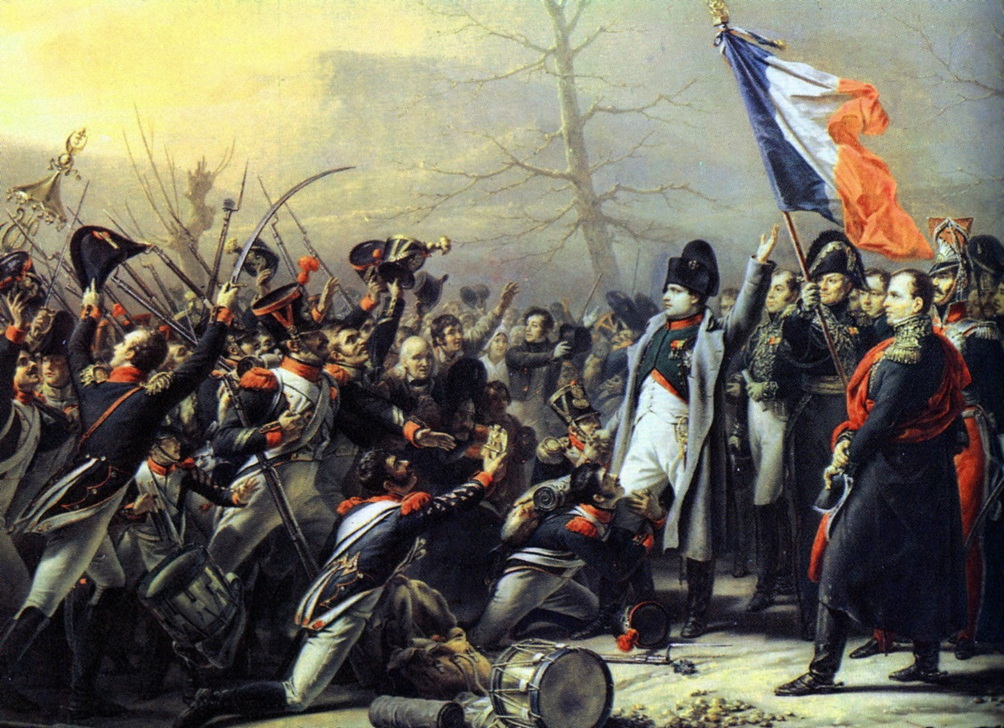

Making France Strong
In 1799, Napoleon helped to overthrow the inefficient and dishonest Directory which was the governing power of France. When he took power as the First Consul, he made laws the same across all of France. The new book of laws was called the Civil Code or Napoleonic Code. This was one of Napoleon’s greatest achievements. It guaranteed the right of equality, the right to hold property, freedom of religion, and freedom to choose what job you wanted to do. This code is still used today in Quebec and Louisianna. Women lost rights under this code, however. Napoleon believed that women were inferior. The Civil Code placed them under the control of their fathers or husbands who could order them to do whatever they wanted to do and punish them if they disobeyed. Women, who had gained rights during The Enlightenment, felt betrayed by Napoleon.
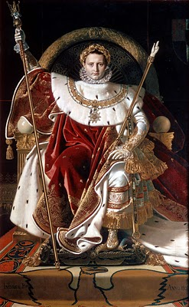
At this time, Napoleon also hired people to rebuild roads, build harbours and canals, build new schools and he kept the price of food low. He filled museums with art and treasures that he had stolen from other countries. The economy in France was still not strong though. Industry was poorly developed and Napoleon placed high taxes on imported goods.
Napoleon the Emperor
The French Revolution brought Napoleon to power, but he did not like the idea of democracy in France. In time, he became more of tyrant than even the rulers like Louis XIV.
Napoleon crowned himself Emperor of France in 1804. He had complete control of the country’s affairs. He had a secret police force who could arrest anyone for almost any reason. He controlled the newspapers, the law and the education system. No one could criticize him. This kind of control is called censorship. Students even had to memorize lessons about his greatness.
Napoleon and Europe
In the 1800’s, Napoleon tried to expand his empire. Britain was his greatest enemy. They gave money and supplies to any country that would fight him. He tried to invade England in 1805 but was stopped by Lord Nelson. England continued to control the seas.
Napoleon tried to stop Britain’s trade with Europe and its colonies like Canada. He punished any European port that allowed British ships to dock. Legal trading was cut off and illegal trading became the way to get goods from Britain to Europe. European ships were not allowed to trade so this was bad for business. Britain also made it illegal for ships from other countries like the United States to trade with France or its empire.
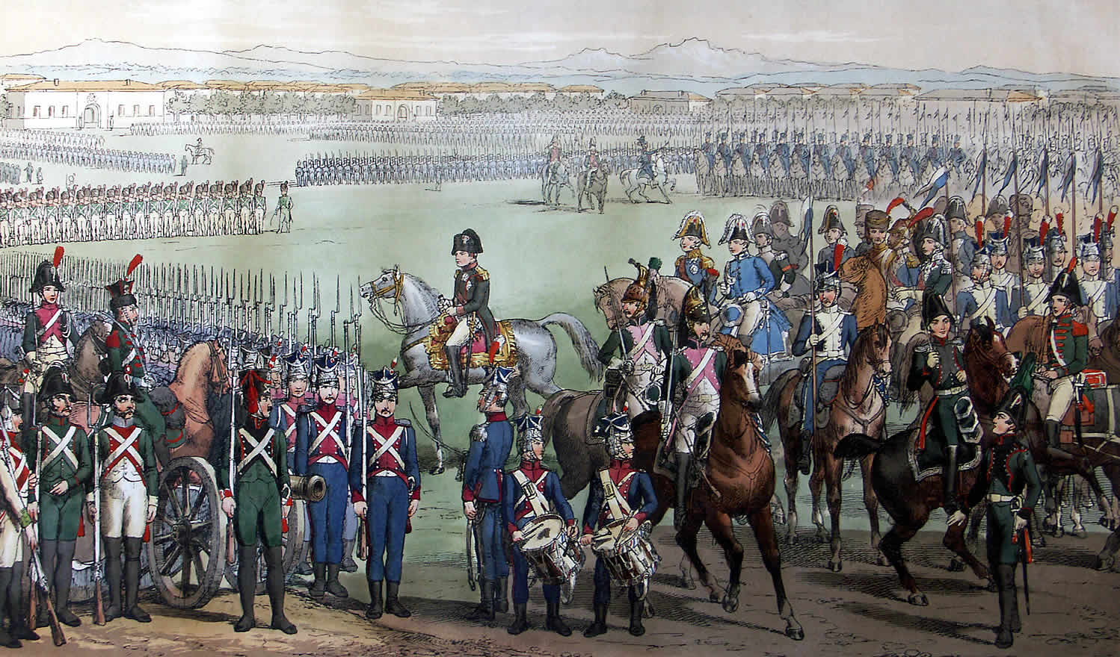
Napoleon continued to take over Europe. He won battles in Austria, Russia and Prussia. The Treaty of Tilsit divided Europe into new countries and provinces. Napoleon, or members of his family, became the monarchs of Italy, Naples, Spain, Sweden, Germany and Holland. Only Great Britain remained independent. All other parts of Europe were under his power. He got rid of the old class system and gave equal rights to all. He brought in the Napoleonic Code of law and encouraged religious freedom.
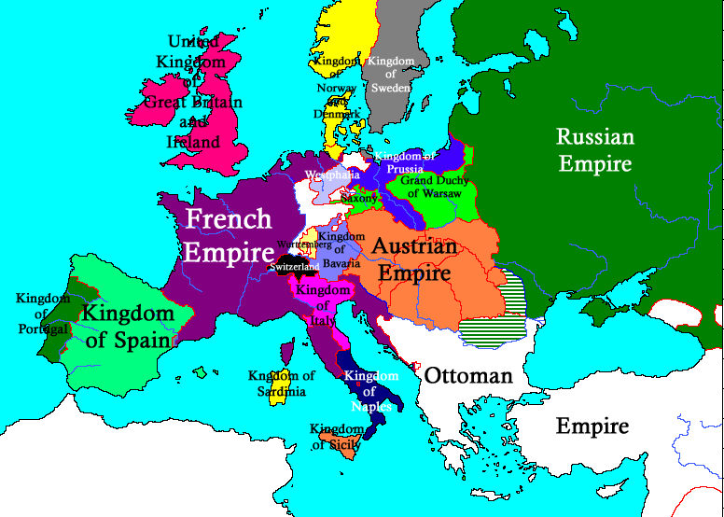

The Rise of Nationalism
Many empires which were conquered by Napoleon’s revolutionary soldiers were happy. They were happy about the ideas of freedom and equality. The French were proud of their country and what they had accomplished. They had their own nation with their own language, culture, history and ethnic background. This idea of a people creating their own nation or nationalism was very popular with the people of Europe. They hated their Austrian rulers and wanted their own nations. Napoleon promised to help people who wanted to create their own nation. This helped him to destroy the Austrian Empire.
Nationalism can bring a country together when all share the same values but it can also tear it apart when people of different races or religions share the same country. This has happened many times in history when one group tries to overtake all others in a country.
Not all the monarchs from Napoleon’s family were accepted where they were sent to rule. Some Europeans thought Napoleon was a tyrant and all they had done was to replace one bad government with another. This feeling was particularly strong in Spain. The people rebelled against Napoleon’s brother Jerome. The British sent troops to help the Spanish, and in the end, Napoleon lost.
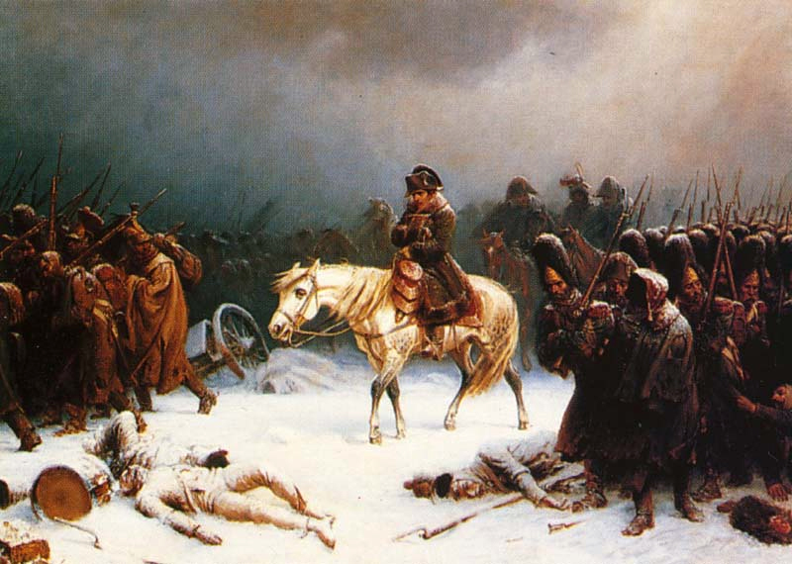
France was friends with Russia and at first they agreed to stop trade with Britain. Later the Russian tsar (monarch) changed his mind and so Napoleon declared war. He gathered 600,000 soldiers of many different nationalities. Napoleon promised these soldiers they could form their own countries after this war. Although Napoleon won some battles at the beginning, the Russians refused to surrender. Napoleon’s soldiers were frustrated and the hard winter weather made things worse. Eventually, there were only 9,000 soldiers left and Napoleon abandoned them and returned to France defeated.

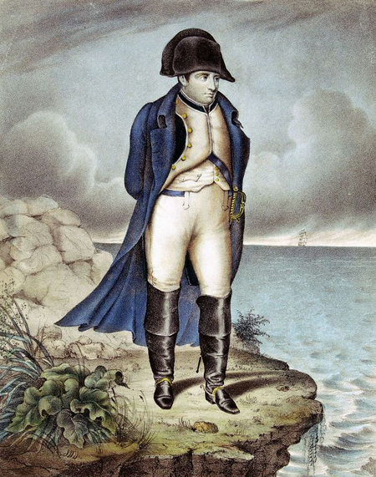
Abdication and Exile
Napoleon’s defeat in Russia seriously damaged his empire. He wasn’t ready to give up though and was able to recruit a new army to continue his fight against the Austrians, Prussians and Russians. He won a few battles but his empire was breaking up. Sweden joined the troops who were fighting against Napoleon. He lost an important battle at Leipzig and another near Paris. He gave up his throne and was exiled to the island of Elba where he became the Emperor. When Napoleon gave up his title and powers, this marked the end of the last stage of the French Revolution.

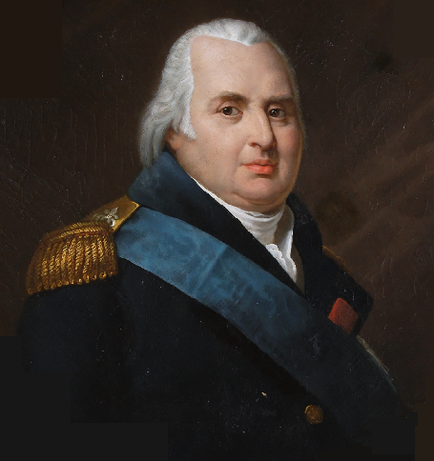
Louis XVIII was invited to be King of France. He was very unpopular because he did not support the revolutionary views of the people. Louis wanted to bring back the Devine Right of Kings. Louis’s supporters began to torture and murder Napoleon’s supporters. Many people wanted Napoleon to return as king.

Napoleon was not happy as the Emperor of Elba. It was just a tiny island. After 10 months in exile, he decided to return to France with 1,000 soldiers. The king’s soldiers came over to Napoleon’s side and forced King Louis to leave the country. Within a couple of months, he had 300,000 soldiers and he was ready to march his army into Belgium.
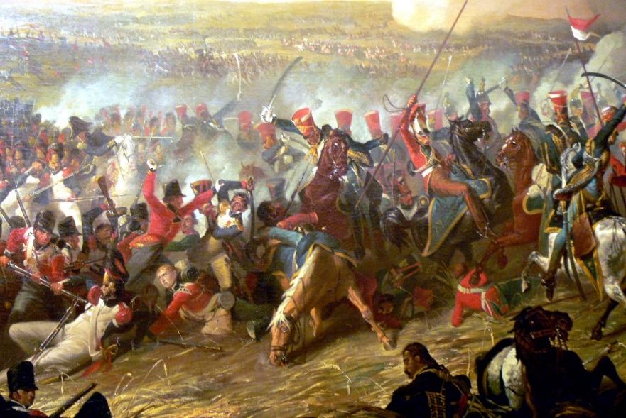
In the Battle of Waterloo, he fought British and German troops. At this famous battle almost 50,000 soldiers were killed in one day.

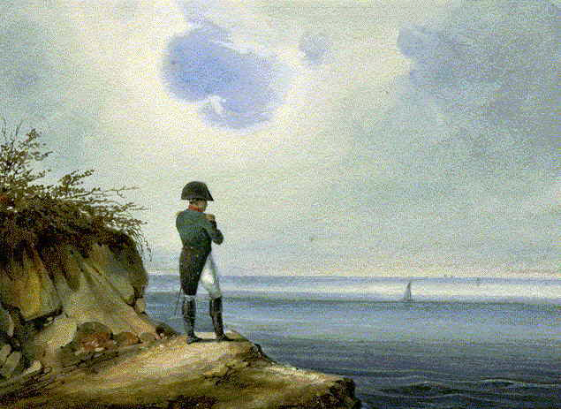
Napoleon was defeated at Waterloo. He was captured by the British and exiled to the island of Saint Helena where he remained a prisoner until he died in 1821.

Louis XVIII soon returned to the throne. The governments of Britain, Russia, Prussia and Austria decided how Napoleon’s empire should be broken up and governed. France was allowed to keep her old borders. Britain took over many overseas colonies. Belgium and Holland were made into one kingdom. Much of Italy was given back to Austria. Britain tried to make sure all countries had a balance of power to stop further wars.
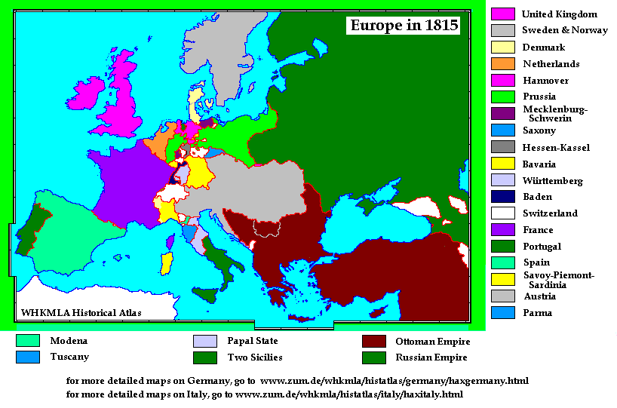

References
This content has been adapted from Crossroads: A Meeting of Nations , Michael Cranny, Prentice-Hall, Toronto, 1998. Chapter 4.
Images
http://en.wikipedia.org/wiki/File:Napoleon_-_2.jpg
http://knarf.english.upenn.edu/Gifs/napoleon.gif
http://en.wikipedia.org/wiki/Napoleon
http://1.bp.blogspot.com/_CJCM6XRXugI/S3yLtIUqJ7I/AAAAAAAACt4/aTBCqp1dmdY/s400/Ingres,_Napoleon_on_his_Imperial_throne.jpg
http://1.bp.blogspot.com/_CJCM6XRXugI/S3yLtIUqJ7I/AAAAAAAACt4/aTBCqp1dmdY/s400/Ingres,_Napoleon_on_his_Imperial_throne.jpg

http://www.anselm.edu/academic/history/hdubrulle/ModernEurope/Class2012/grading/food/fdwk04b.htm
http://upload.wikimedia.org/wikipedia/commons/c/cc/Napoleons_retreat_from_moscow.jpg

http://blogs.ancestry.com/circle/?p=2312

http://upload.wikimedia.org/wikipedia/commons/a/a9/Louis_XVIII_of_France.png

http://upload.wikimedia.org/wikipedia/commons/a/aa/Plas_Newydd_(Anglesey)_-_Waterloo_1.jpg

http://upload.wikimedia.org/wikipedia/commons/7/71/Napoleon_sainthelene.jpg
http://www.anselm.edu/academic/history/hdubrulle/ModernEurope/Class2012/grading/food/fdwk04b.htm

